**COMMON LIBRARY REFERENCES**YOUTUBE LINK - <https://www.youtube.com/watch?v=eZDx2G0E-dQ>

Commands Screenshot

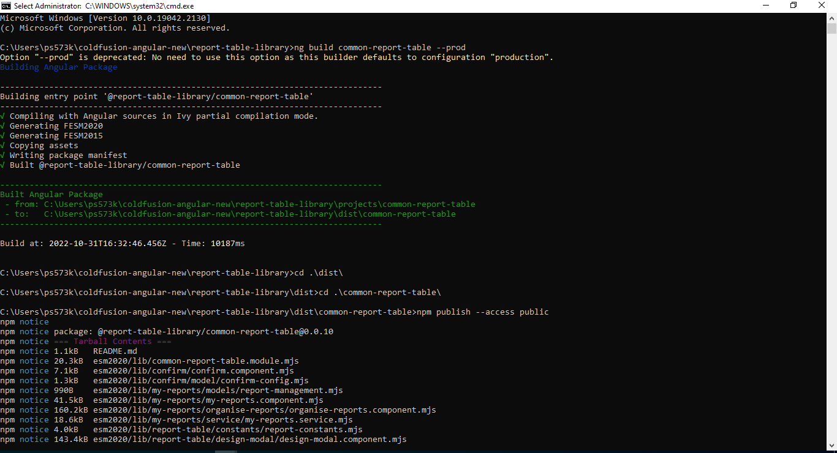

To generate library - ng g library common-report-table

To build - ng build common-report-table

To publish - npm publish --access public

To create new component in library – ng g c “comp name” –project common-report-table

**When we publish for first time any Library**

To publish generate target file - npm pack (For first time)

Make account in npm.js

To publish as npm package - npm adduser (it will ask for username , password and email)

To publish - npm publish –access public